Business Report
  - YEAR IN REVIEW
 | CAC 2000 Limited |  | www.cacjamaica.com

CEo Report

Y/E Oct 31, 2023

Year IN Review

To say that this year was a challenging one, would be an understatement, however at CAC 2000 Limited we view every challenge as an opportunity to “Improve People’s Lives” be that the life of a person or company.

This year we started with what would be our lowest ever project portfolio since 2000, which was as a direct result of COVID and so 2023 became the year of rebuilding, rebranding, changing of processes and redefining ourselves strategically for the future.

As a result of the portfolio size, we knew that achieving a profit in 2023 would be difficult as Commercial Projects has been the bread and butter of the company from the get-go. We could have given up, but with our staff and investors in mind, we as a Team became even more determined to not only rebuild our portfolio to better than pre-covid levels, but to also diversify the company’s revenue streams to minimize the risk of being too dependent on Projects in the future.

Some of you may be asking; “Does this mean CAC is no longer focused on providing the B2B market with engineered solutions?” And the answer is a resounding “NO,” instead we are growing and expanding as a company as we focus on our vision of excelling as the leading experts on energy and indoor environmental quality (IEQ), which encompasses all aspects of Air Conditioning, along with solar, lighting, water purification, air quality and tri-generation in both the B2B and B2C market.

Whilst CAC did not realize a profit in 2023, I am happy to report that our project portfolio going into 2024 is very healthy and we continue to aggressively pursue wins in all areas of energy and Indoor Environmental Quality (IEQ). We are thrilled that our service levels have returned to normalcy, and we expect our service portfolio to grow by at least 10-15% in 2024 and 2025, as we remain committed to working with our customers to expand the lifespan and efficiency of their equipment and address SDG #3,6,7,9 and 13 under the Global Goals adopted by the UN in 2015 for completion by 2030.

In the subsequent section we have highlighted the major changes that have been implemented as a direct response to the challenges we faced in 2023, although instead of labelling them as challenges we have labelled them as opportunities.

The Opportunities

RETAIL – HERE WE COME:
2023 saw the opening of CAC’s first retail outlet at Village Plaza (Figure 1) – this was a learning experience, but addressed one of our major strategic priorities of diversification as we learned the hard way what happens when as a company you are too dependent on one major revenue stream. And of course, as is said sometimes opportunity knocks at what seems to be the most inopportune time. This was the case when we got a call regarding a potential retail outlet in Montego Bay, and we responded to the knock by opening our second retail outlet in Montego Bay at the National Supply Complex (Figure 2). Village Plaza is holding its’ own, however it is still early days yet for Montego Bay, but we do expect to see a continued overall uptick in sales.

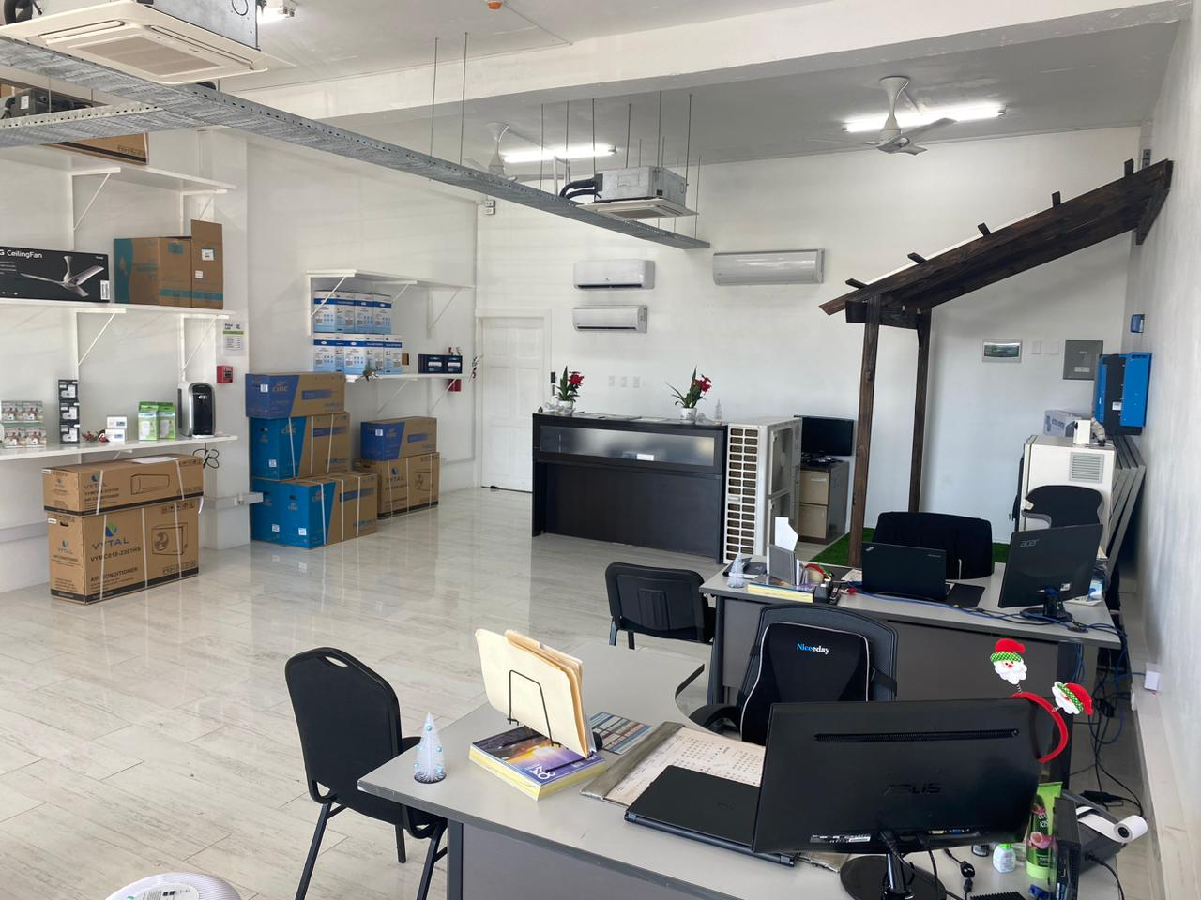
Figure 1 – Village Plaza

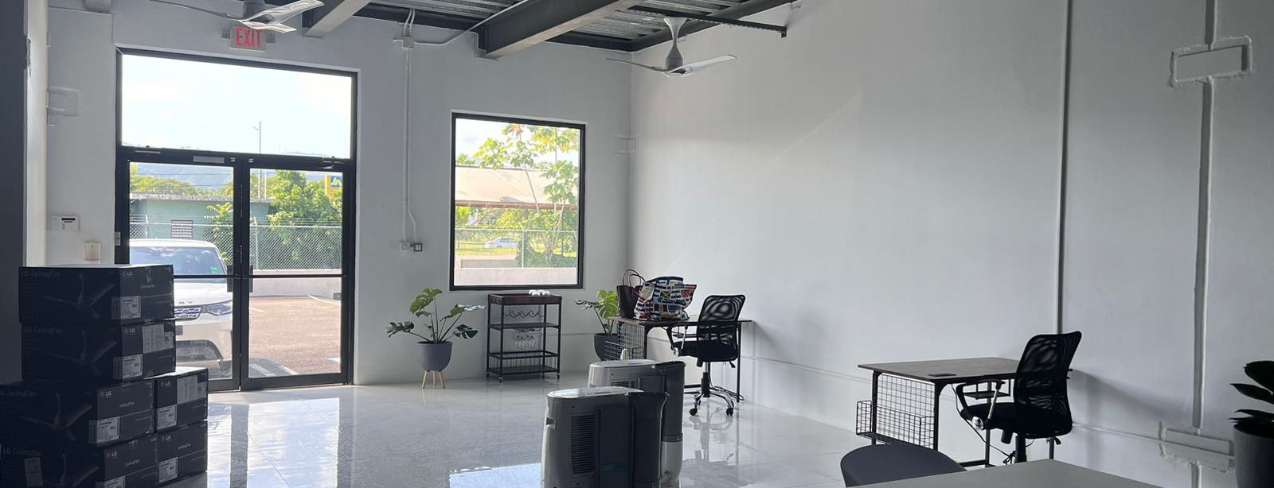
Figure 2 – Montego Bay National Supply Complex

CAC Launches VYTAL

Another monumental achievement was the launch of our own brand – VYTAL, with the first shipment coming to market in September 2023. This too was quite a learning experience as the trademark process took well over a year to complete, but the dedication of the Team kept us on the straight and narrow path to a successful September launch (Figure 3).

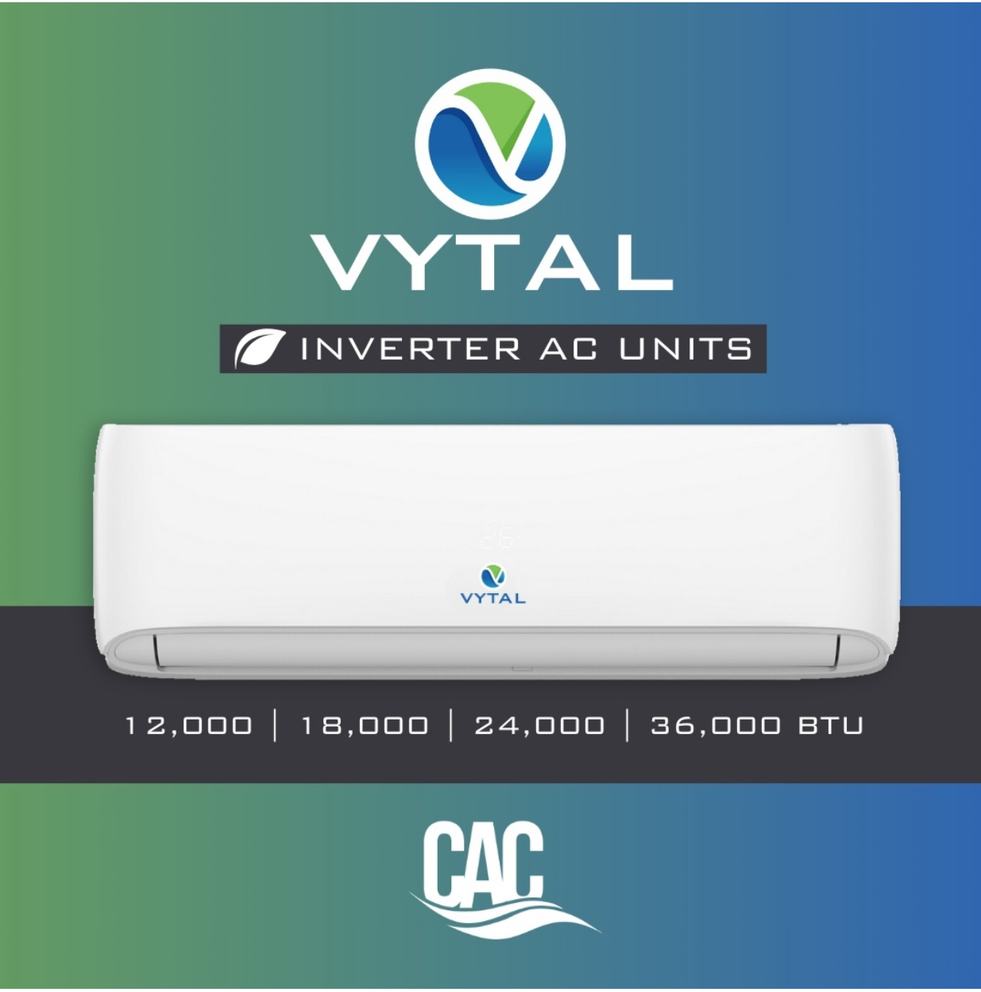

Figure 3 – Vytal Brand

CAC Processes and Staff Improvement:

We have been instituting many process changes within the company, and as with all changes there have been teething pains, however we recognize that once these changes have been fully implemented, we stand to be an overall leaner more efficient company. Project Management experts have been engaged to upskill our Project Engineers and plans are in place for further training in 2024.

All in all, it has been a year of growth and while our numbers do not reflect same, we know that strategically we needed to take a step back and reengineer ourselves for the future.

The Results:
CAC dropped in revenues to $823M or 29% over last year revenues of $1.1B, and while we were able to contain/reduce our overall operating expenses by 18% (319M vs. $390M), we did realize a loss of $98.2M versus a profit of $20.4M over last year.

Cashflow has been a big concern for us this year. Longer shipment times due to the movement of manufacturing to China, and increased demand for funds for the clearance of containers versus less than container loads (LCL) have resulted in a reduction of time to dispose of inventory before the supplier invoice becomes due for payment. This truthfully has been the biggest challenge for CAC in 2023.

To this end we saw our inventory days go from 162 days to 222 days over last year or a 37% increase, along with an increase in our debtor days from 154 to 190 days or 23% as well as an increase in our creditor days from 75 days to 103 days or 37% - which further cements the correlation between inventory turns, receivables and payables.

Another use of cash which has been a big change in the industry is the extensive requirement for Bonds on projects such as Mobilization Bonds, Performance Bonds and Advance Bonds, all of which ties up the cash on hand, as well as having a negative impact on our Interest Expense and Bank Charges.

While this may paint a negative picture the fact is that CAC’s operating cash has improved significantly over last year, even though said cash is tied up on multiple projects, hence our strategy of aggressively expanding the business to minimize the effect of logistics and projects on the day-to-day operation of the business.

We are very optimistic that what we have in the pipeline, the turnaround of our service department to pre-covid numbers, the expansion of our product line, our retail stores along with our proposed E-Commerce strategy for 2024 will enable CAC to address many of the cashflow issues being experienced.

To our investors who continue to believe in CAC 2000 Limited, I will say that I personally am feeling bullish on CAC 2000 Limited based on our in-hand project pipeline, our service portfolio, along with our aggressive approach to expanding our retail presence in the Jamaican market over the next 2 years.

I look forward to many exciting things in 2024 and beyond, and whilst I am not happy with our results, I do believe that what we have put in place throughout this year will reap rewards in the upcoming years.

I look forward to serving your best interest in 2024.

Sincerely,

Gia Abraham, BSc., C.Dir, M.CI.D
Chief Executive Officer

