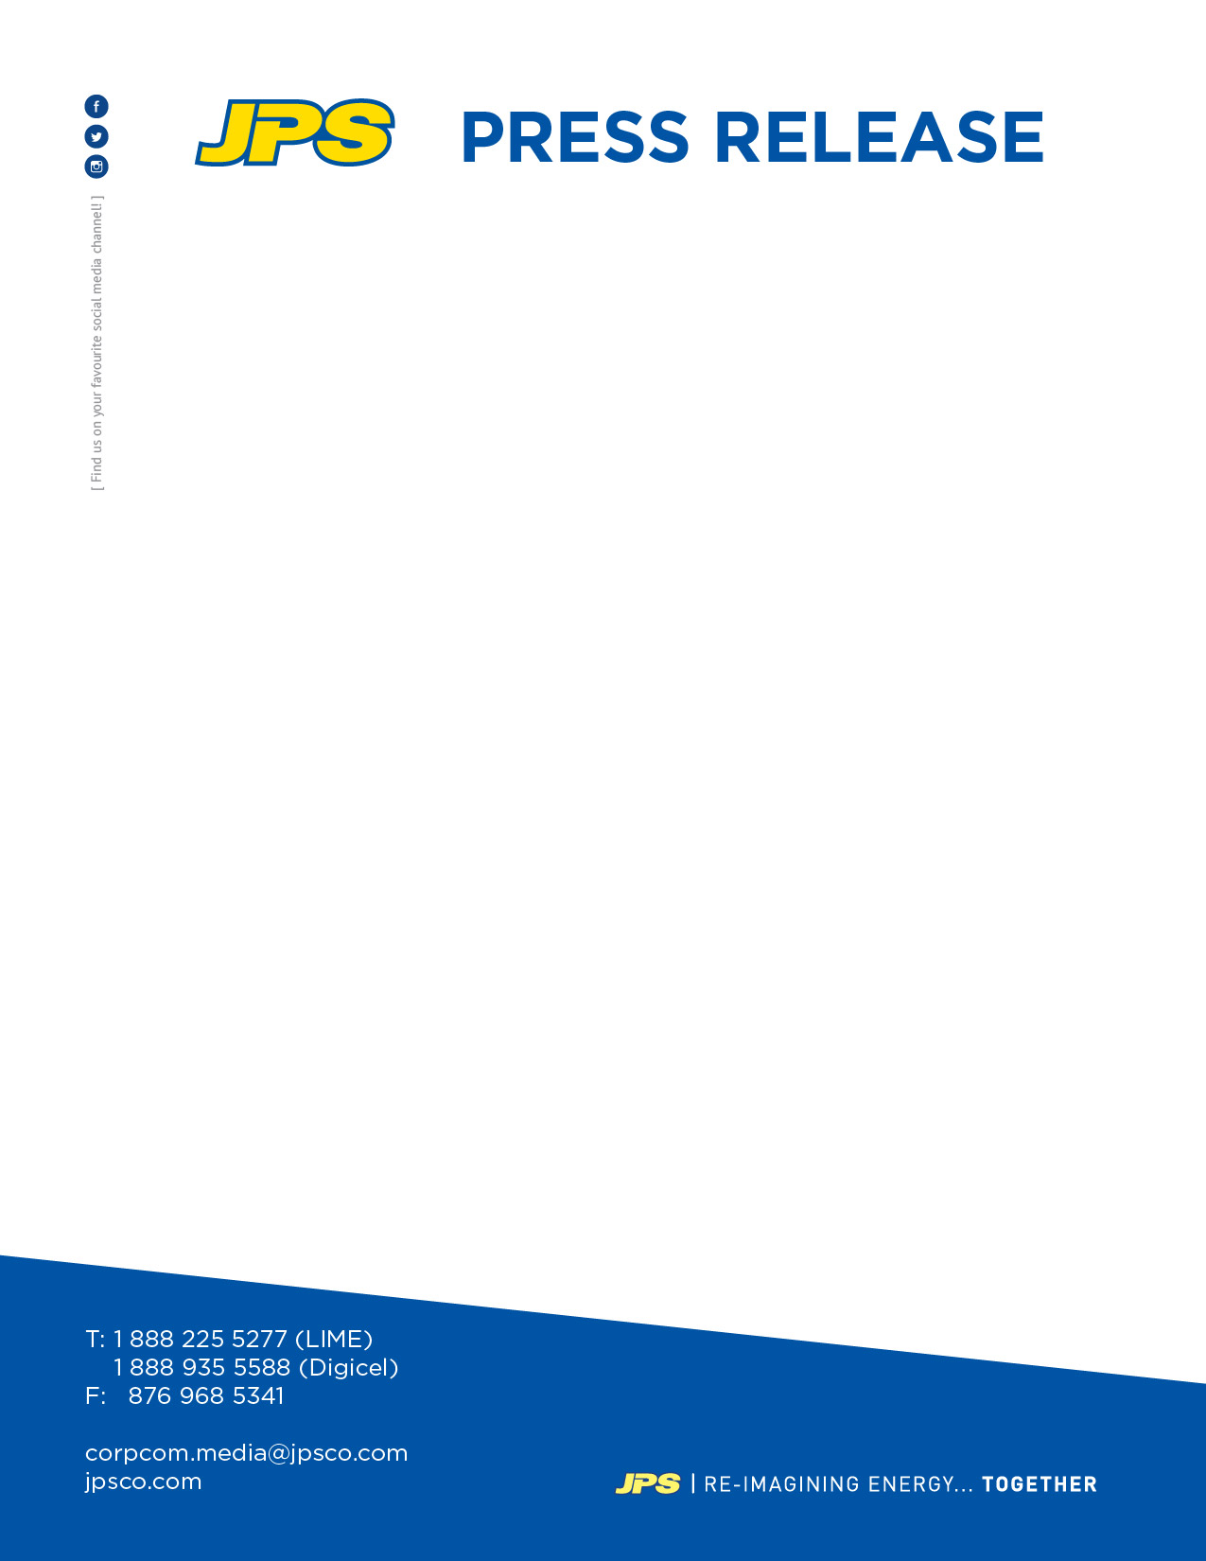

NEW MILESTONE ACHIEVED ON 190MW PROJECT RENAISSANCE:
JPS Finalizes Agreement for Equipment and Financing for New Power Plant

Thursday, September 22, 2016

KINGSTON, JAMAICA: Jamaica’s energy company, JPS, has announced the finalization of an agreement with General Electric (GE) for the manufacturing of equipment for its 190MW power plant, Project Renaissance.

JPS, through its subsidiary, South Jamaica Power Company (SJPC), this week confirmed GE’s role as the Original Equipment Manufacturer (OEM) for the project, with the signing of the agreement, which secures the delivery schedule for all major equipment for the new plant.

“This is a significant milestone, which will allow us to move to the next stage of the project,” explained JPS President & CEO, Kelly Tomblin. “In addition to the agreement with GE, SJPC has also selected the Engineering, Procurement and Construction (EPC) Contractor, and secured all the financing for the new power plant project. Financing of approximately US$210 has been secured through a syndicate of banks, led by the National Commercial Bank (NCB),” she disclosed.

With the financing, OEM and EPC Contractor now in place, JPS is expecting to move forward with the project in the next 60 – 90 days. “We expect that all the relevant permits will be in place and the loan financing documentation completed within the next two to three months, to facilitate the actual start of construction,” the JPS President & CEO indicated.

Contact: Winsome Callum, 878-3740 / 935-3504

